**Table of Contents**

1. Infrastructure Planning 1

1.1 Proper infrastructure planning is critical to cloud migrations. Considerations migrating to cloud include: 1

1.2 Infrastructure should be planned properly for all multiple services 2

2. Hybrid Cloud Scenario I Drafted in Visio 3

3. Economics of cloud migration 4

3.1 Steps to decide to move to private or public cloud. 4

3.2 Example Cloud Cost Model 4

4. Microsoft Azure Services 5

4. 1 Microsoft Azure has matured as a premier certified and secure cloud provider. 5

4.2 List of Services in Azure Portal 5

5. Azure Product Tool Examples 6

6.1 Declarative model for system configuration management 6

5.2 Azure Resource Manage (ARM) 6

5.3 Azure Resource Templates 7

5.4 Resource Groups 7

5.5 PowerShell 8

6. References 9

## 1. Infrastructure Planning

### 1.1 Proper infrastructure planning is critical to cloud migrations. Considerations migrating to cloud include:

* Cost, Disaster Recovery, Availability, Efficiency, Scalability, and Reliability

### 1.2 Infrastructure should be planned properly for all multiple services

* Application development, IT operations, legal, finance, procurement, security, compliance, privacy, identity management, data integration, mobility, customer experience, and business development.

Figure 1.3 – Cloud Migration Process Diagram

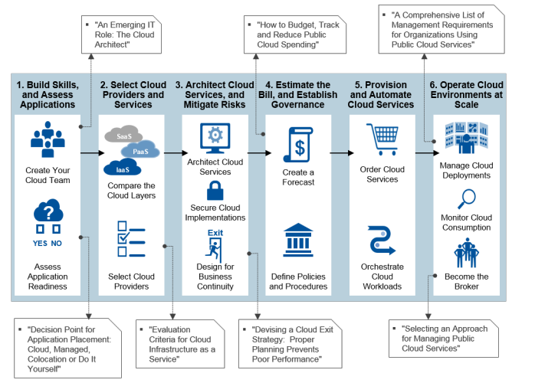

## 

## 2. Hybrid Cloud Scenario I Drafted in Visio

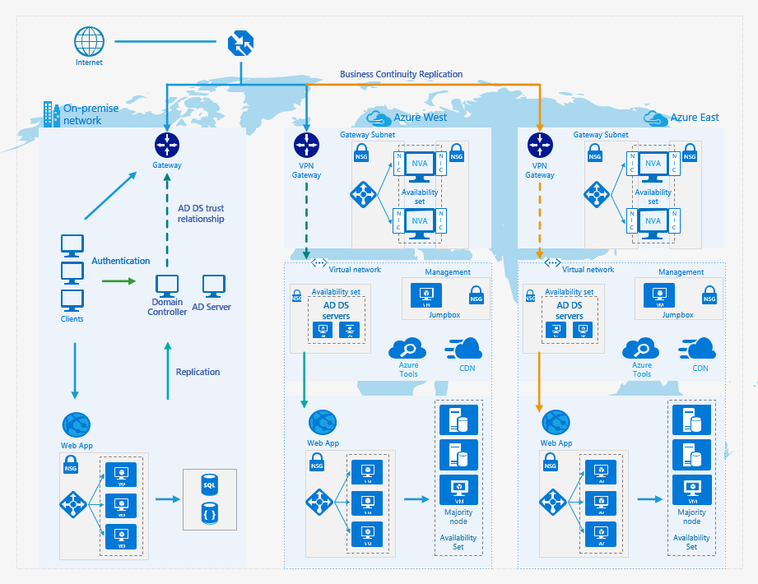

## 3. Economics of cloud migration

### 3.1 Steps to decide to move to private or public cloud.

#### Step 1: Pre-Migration

* 1. Develop baseline total cost of ownership
  2. Discover transformation drivers

#### Step 2: Business Case

* 1. Create business case for cloud transformation
  2. Compare On-premises to pubic total cost of ownership

#### Step 3: Migration at Scale

* 1. Prioritize workload migration based on economic drivers
  2. Measure ongoing value of cloud adoption

#### Step 4: Evergreen

* 1. Uncover under or over-utilized resources
  2. Model potential impact of new cloud services

[3]

### 3.2 Example Cloud Cost Model

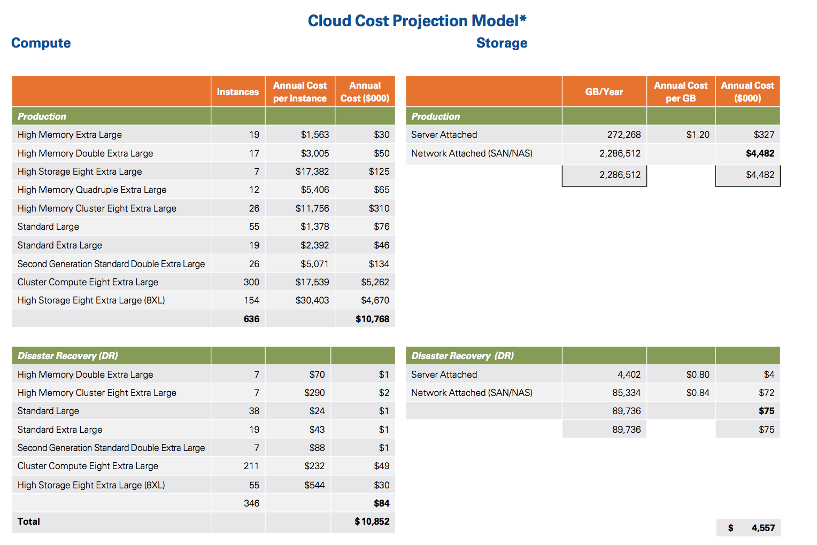

## 4. Microsoft Azure Services

### 4. 1 Microsoft Azure has matured as a premier certified and secure cloud provider.

* Azure products are compatible with existing Microsoft applications such as .Net, C#, F#, and Visual Basic.
* Azure is compatible with other software applications such as Python, Ruby, Node.JS, Java, and JavaScript.

### 4.2 List of Services in [Azure Portal](https://azure.microsoft.com/en-us/services/?query=)

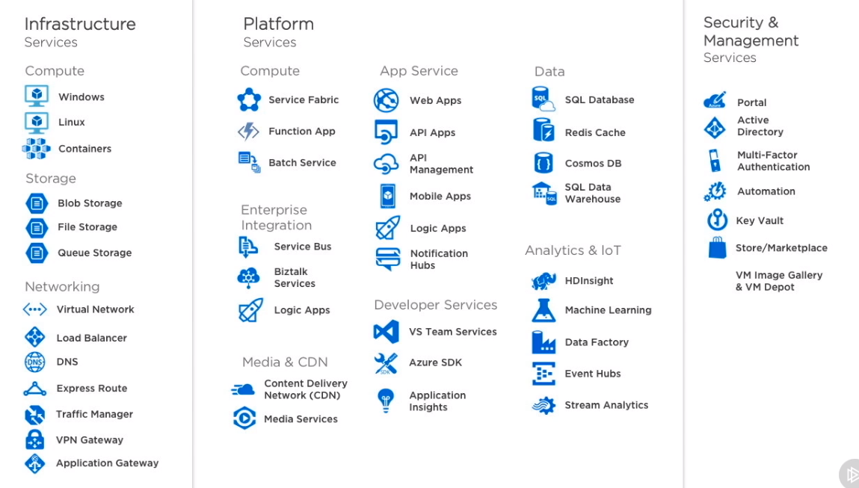

## 5. Azure Product Tool Examples

## 6.1 Declarative model for system configuration management

* Simplify system administration task by configuring one or more devices automatically
* Configure machines identically for standardization
* Keep systems in sync to avoid drift
* Deployment on demand
* Works alongside other configuration management tools such as Chef or Puppet

Figure 5.11

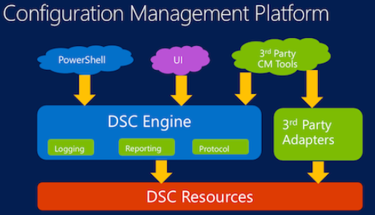

## 5.2 Azure Resource Manage (ARM)

* Deploy, manage, and monitor all the services for your solution and application as a group
* Continuous deployment allows your solution to have a consistent state throughout the development lifecycle
* Apply access control to all resources in your resource group
* Apply tags to resources to logically organize them holistically
* Use pre-existing JSON templates to manage resources and groups

## 

## 5.3 Azure Resource Templates

* JSON files that define the resources you need to deploy your solution
* Use tooling such as Visual Studio with Azure SDK or Visual Studio Code to create JSON templates
* Define $schema, contentVersion, parameters, variables, resources, and outputs
* You can find a list of Quickstart templates [here](https://azure.microsoft.com/en-us/resources/templates/)

Figure 5.31

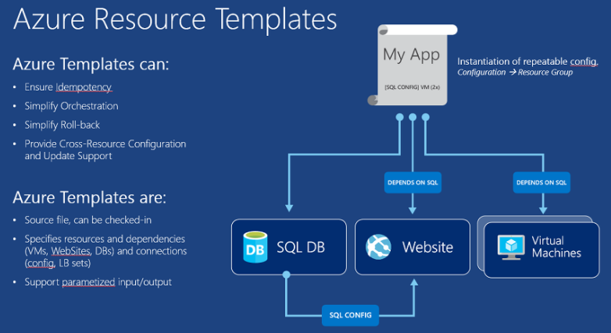

## 5.4 Resource Groups

* Monitor, control access, provision, and manage billing for a collection of assets that are required to run an application.

Figure 6.41

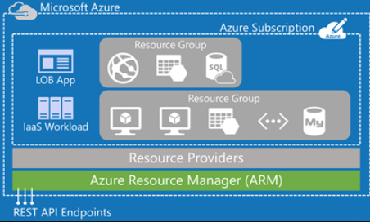

## 5.5 PowerShell

* Task automation and configuration management framework from Microsoft
* PowerShell ISE Integrated Scripting Environment tool available for multiple commands and script writing
* Manage remote resources and script configuration management DSC.

Figure 5.51 Example PowerShell script

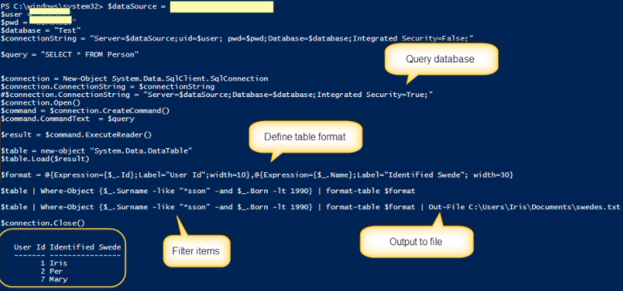

## 6. References

1. [Header](http://www.eausergroup.com/) Image
2. [Figure 1.3 Infrastructure Planning](https://www.pluralsight.com/courses/cloud-architecture-foundations?twoid=faa01120-e1a3-4665-9de8-14ac2568ab36)
3. [Figure 3.2 Cloud Economics](https://assets.kpmg.com/content/dam/kpmg/pdf/2015/11/cloud-economics.pdf)
4. [Figure 5.11 Desired State Configuration](https://www.google.com/url?sa=i&rct=j&q=&esrc=s&source=images&cd=&cad=rja&uact=8&ved=0ahUKEwjS0_mss7XXAhVF82MKHZ_nDy8QjRwIBw&url=https%3A%2F%2Fwww.infoq.com%2Fnews%2F2014%2F05%2Fpowershell-dsc-takes-on-linux&psig=AOvVaw0613-9539aD8MYEmoFxwyU&ust=1510451196409021)
5. [Figure 5.31 Azure Resource Templates](https://www.google.com/url?sa=i&rct=j&q=&esrc=s&source=images&cd=&cad=rja&uact=8&ved=0ahUKEwif_IC_qLXXAhVNzGMKHYtCDLsQjRwIBw&url=https%3A%2F%2Fzimmergren.net%2Fdeveloping-with-azure-introduction-to-this-article-series%2F&psig=AOvVaw0FyhZsBQk2dpr0UrtP8Kp9&ust=1510448167580425)
6. [Figure 5.41 Azure Resource Groups](https://www.google.com/url?sa=i&rct=j&q=&esrc=s&source=images&cd=&cad=rja&uact=8&ved=0ahUKEwiN_Yfzr7XXAhVOyGMKHYDzB-cQjRwIBw&url=http%3A%2F%2Frickrainey.com%2F2016%2F01%2F19%2Fan-introduction-to-the-azure-resource-manager-arm%2F&psig=AOvVaw1_Ab1A8JVgYCZk6R6SOPLs&ust=1510450248127195)
7. [Figure 5.51 PowerShell example](https://www.google.com/url?sa=i&rct=j&q=&esrc=s&source=images&cd=&cad=rja&uact=8&ved=0ahUKEwins4eBtbXXAhUfHGMKHXdCCvgQjRwIBw&url=http%3A%2F%2Firisclasson.com%2F2013%2F10%2F16%2Fhow-do-i-query-a-sql-server-db-using-powershell-and-how-do-i-filter-format-and-output-to-a-file-stupid-question-251-255%2F&psig=AOvVaw2A4Pjw7zHvgkYRXkK_8Z0D&ust=1510451642746552)